|  |  |  |  |  |
| --- | --- | --- | --- | --- |
|  |  |  |  |  |
| |  |  |  |  |  | | --- | --- | --- | --- | --- | |  |  |  |  |  | |  |  |  |  |  | |  |  |  |  | |  |  |  | |  |  |  | |  |  |  |  | |  |  |  |  |
|  |  |  |  |
|  |  |  |
|  |  |  |
|  |  |  |  |

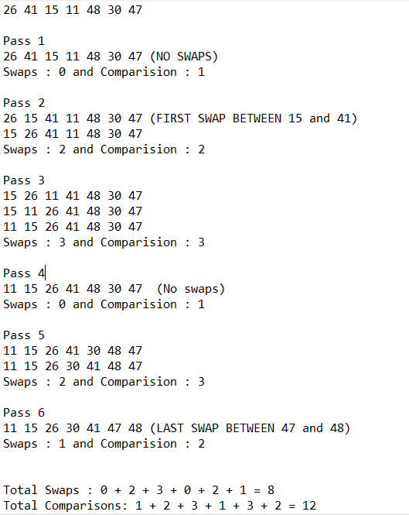

==========================================================

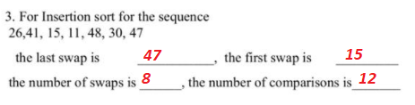

==========================================================

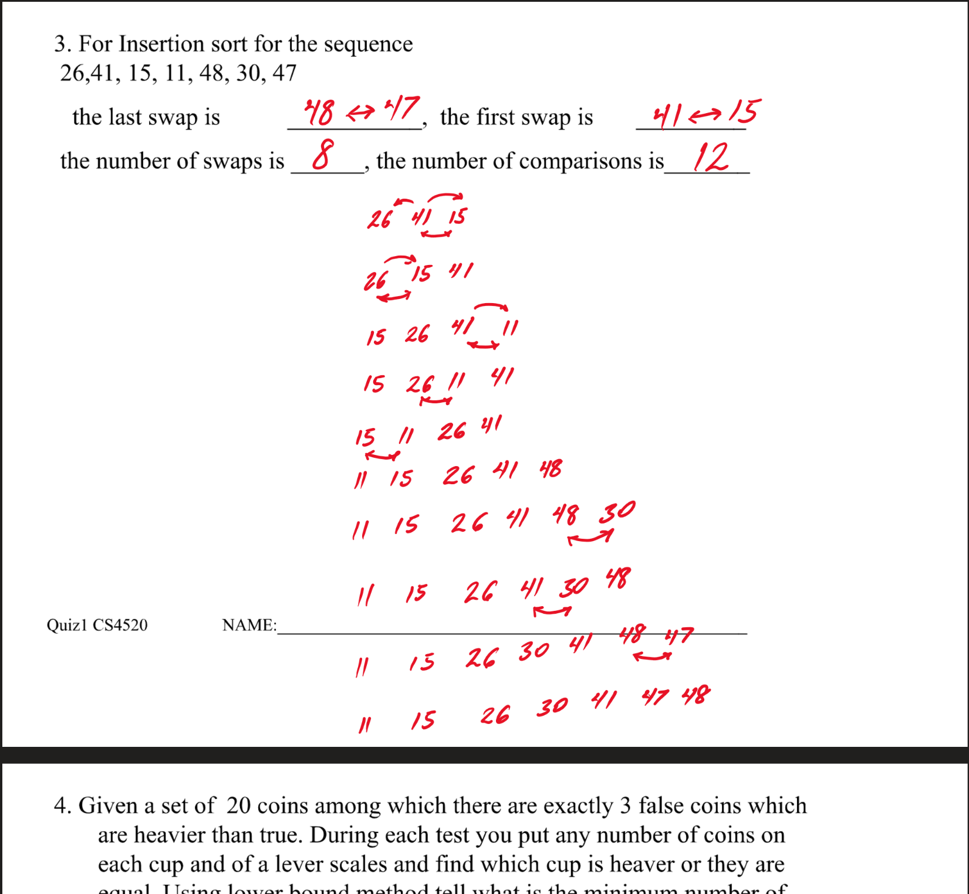

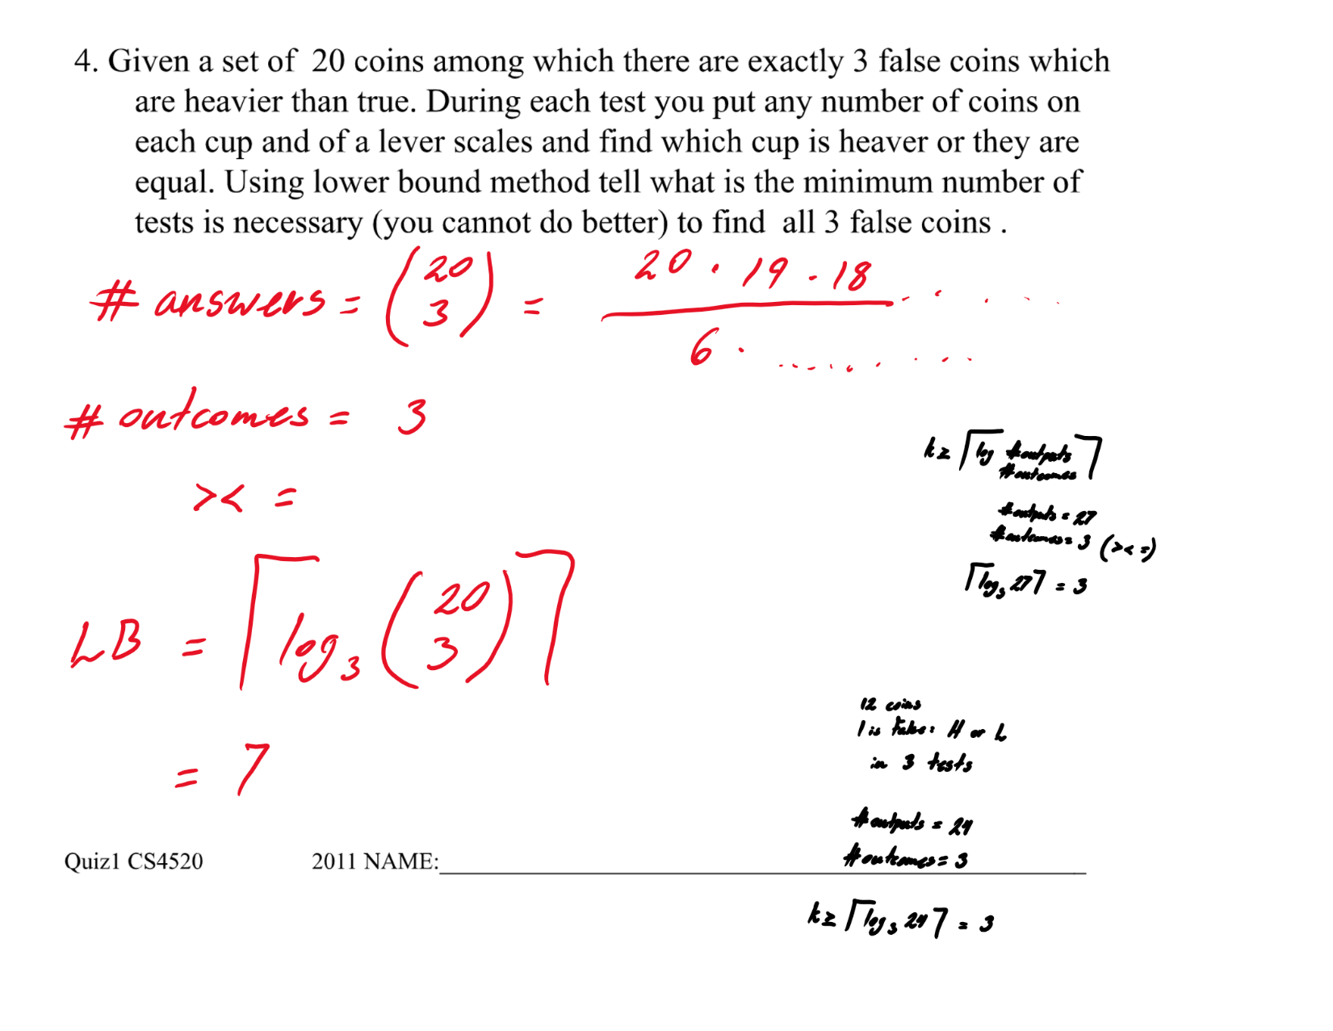

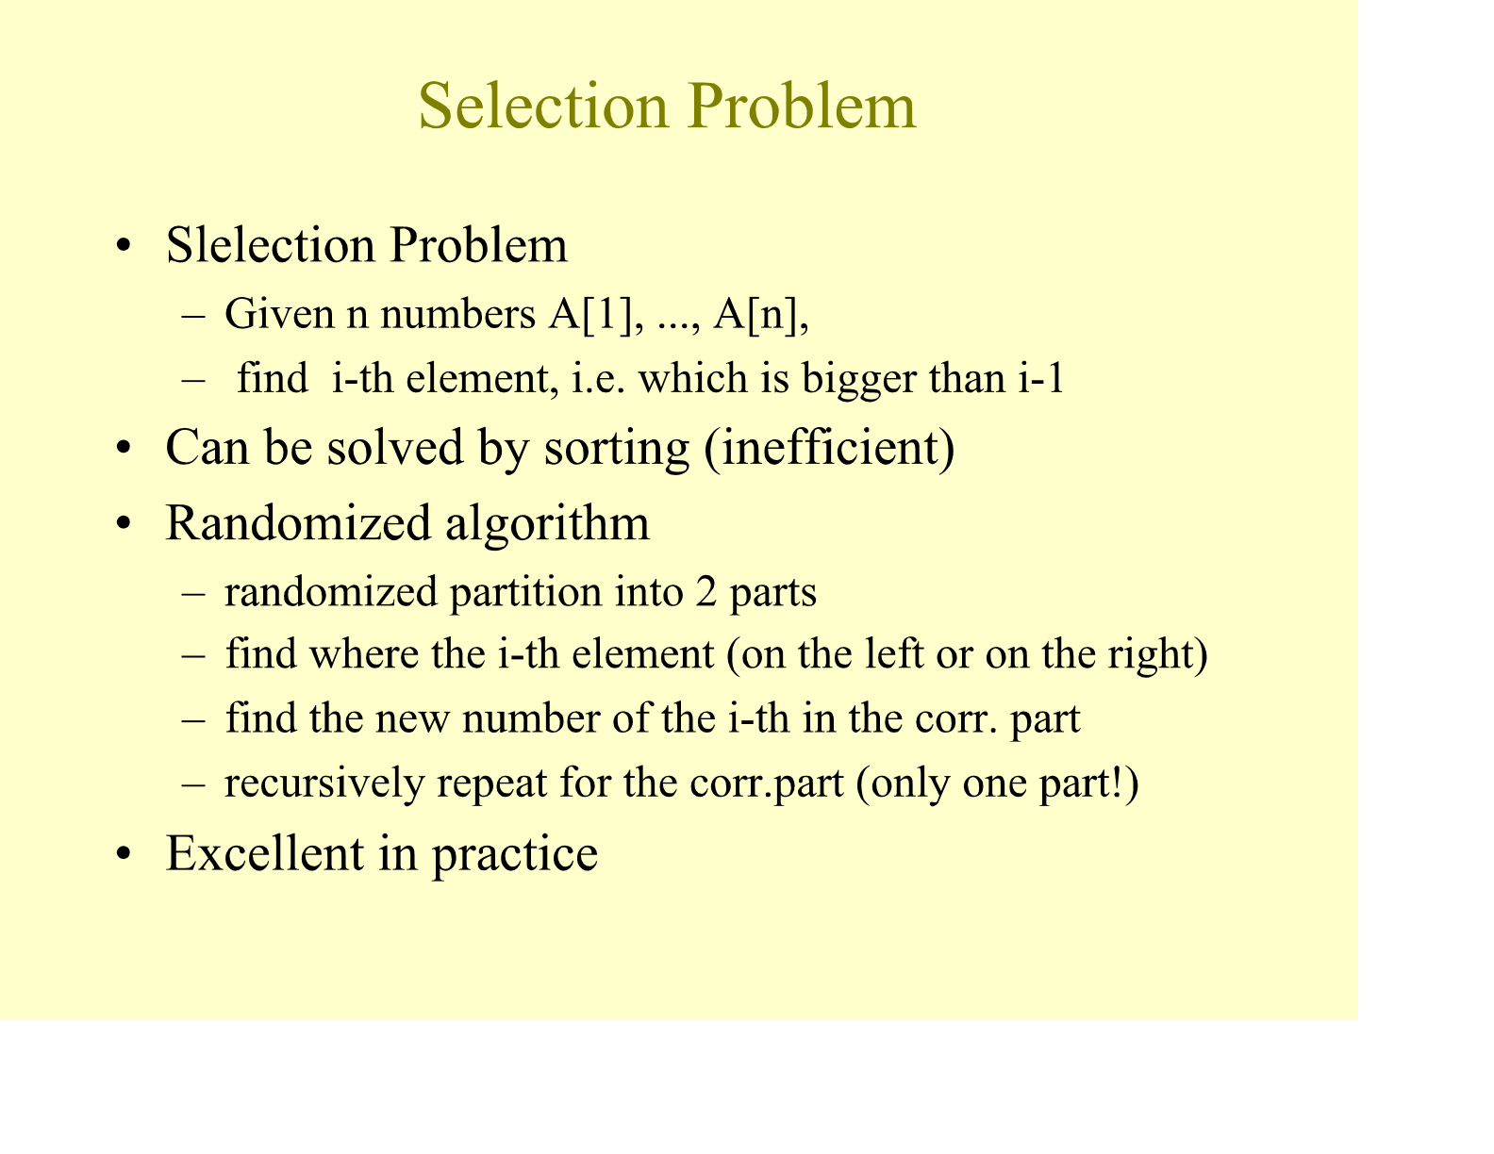

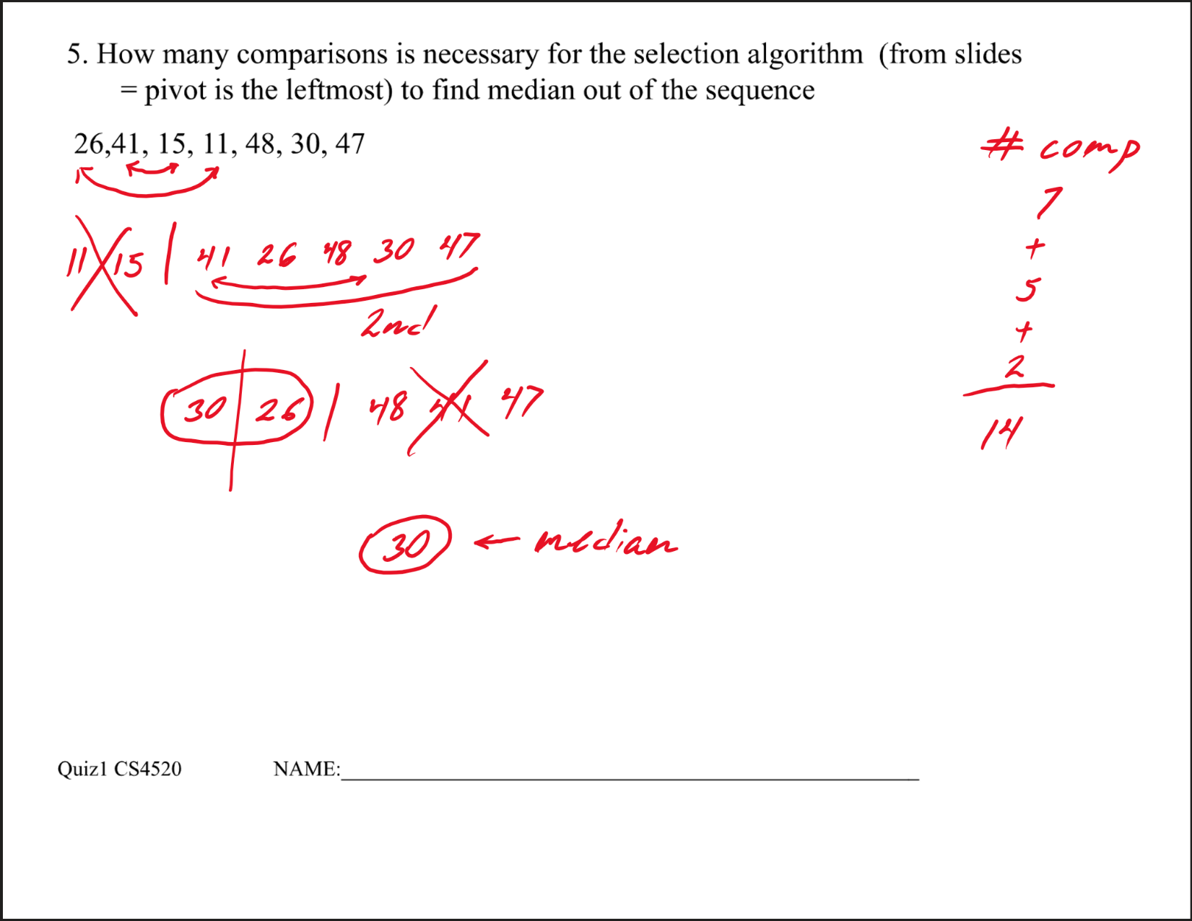

**first iteration :-**

26,41, 15, 11, 48, 30, 47

Compare 26 and 41

Compare 41 and 15

Compare 15 and 11

Compare 11 and 48

Compare 48 and 30

Compare 30 and 47

11 will come at index 1 and 26 will go at index 4

11,41, 15, 26, 48, 30, 47

In first iteration 6 comparisons will be done

**Second iteration:-**

11,41, 15, 26, 48, 30, 47

Compare 41 and 15

Compare 15 and 26

Compare 26 and 48

Compare 48 and 30

Compare 30 and 47

15 will come at index 2 and 41 will go at index 3

11, 15,41, 26, 48, 30, 47

In the second iteration 5 comparisons will be done

**Third iteration:-**

11,15,41, 26, 48, 30, 47

Compare 41 and 26

Compare 26 and 48

Compare 48 and 30

Compare 30 and 47

26 will come at index 3 and 41 will go at index 4

11, 15,26, 41, 48, 30, 47

In the Third iteration 4 comparisons will be done

**Fourth iteration:-**

11, 15,26, 41, 48, 30, 47

Compare 41 and 48

Compare 48 and 30

Compare 30 and 47

30 will come at index 4 and 41 will go at index 6

11, 15,26, 30, 48, 41, 47

In Fourth iteration 3 comparisons will be done

So here we will get median because median of the given array value at index (total_number_in_array +1 / 2)

Hecne index will be (7 + 1) / 2 = 4

We get the value at fourth index as 30. hence we will stop here

and total comparisons are 6 + 5 + 4 + 3 = 18

**Hence answer is 18 comparisons are required to find the median of the given array**

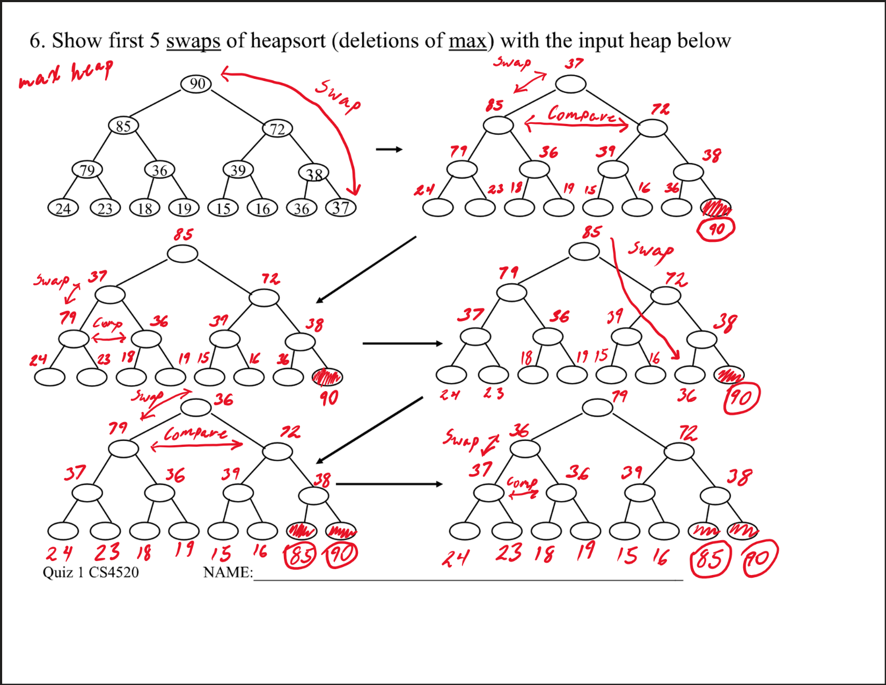

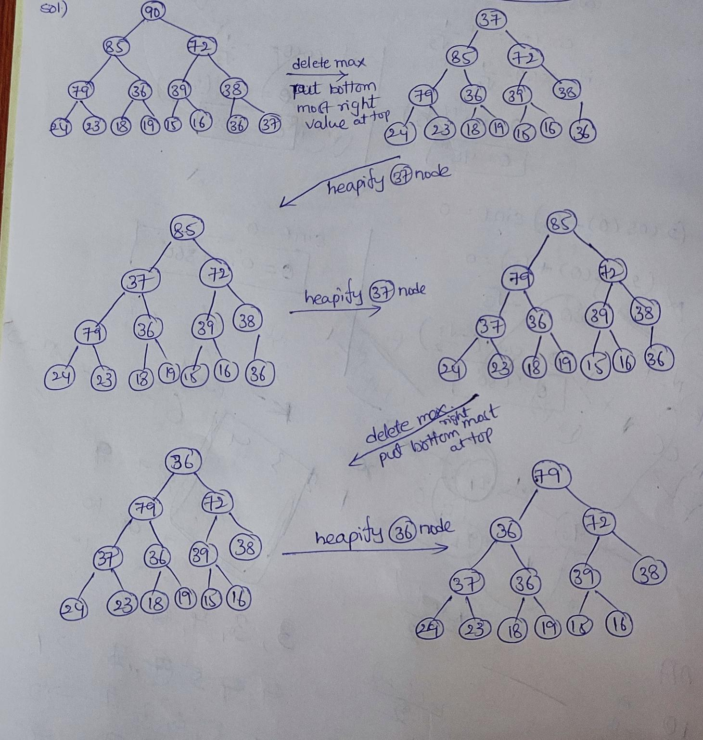  
  
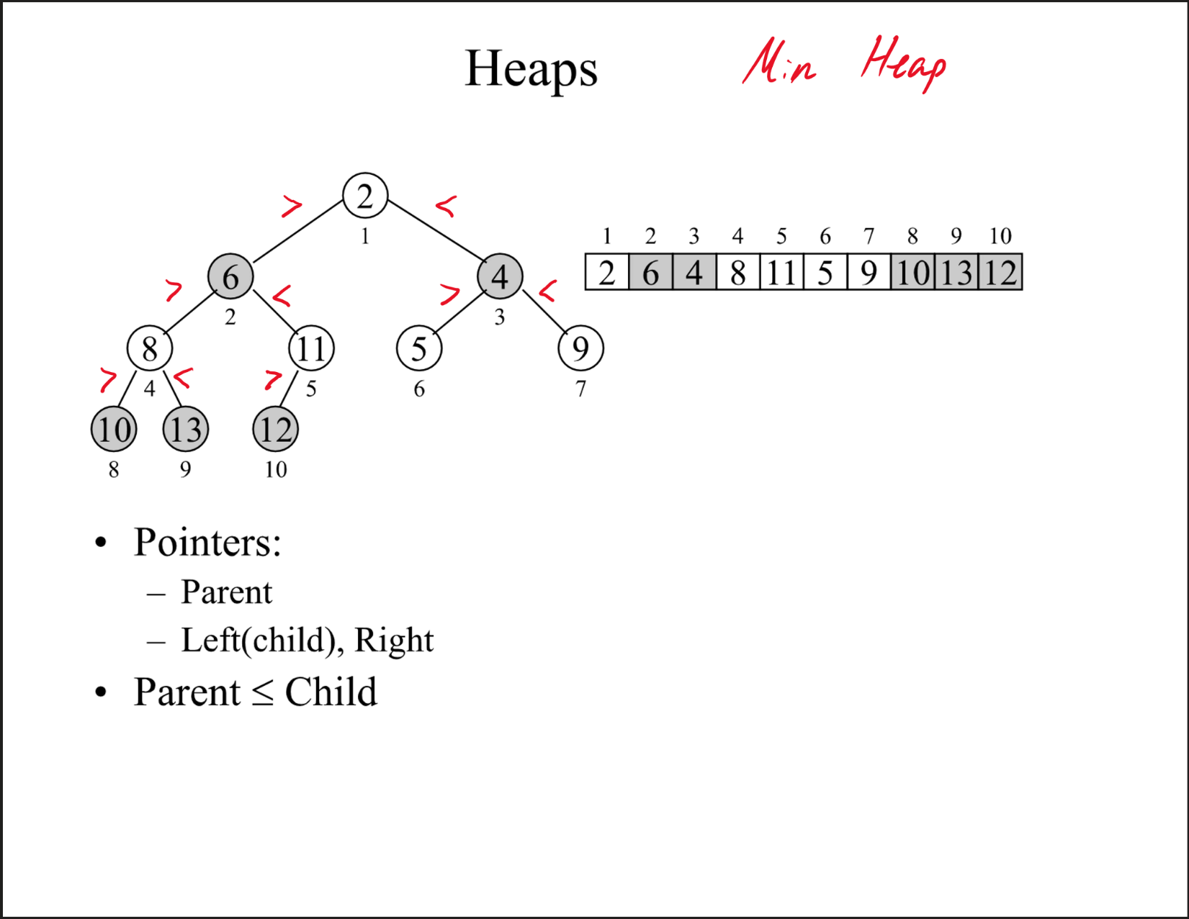

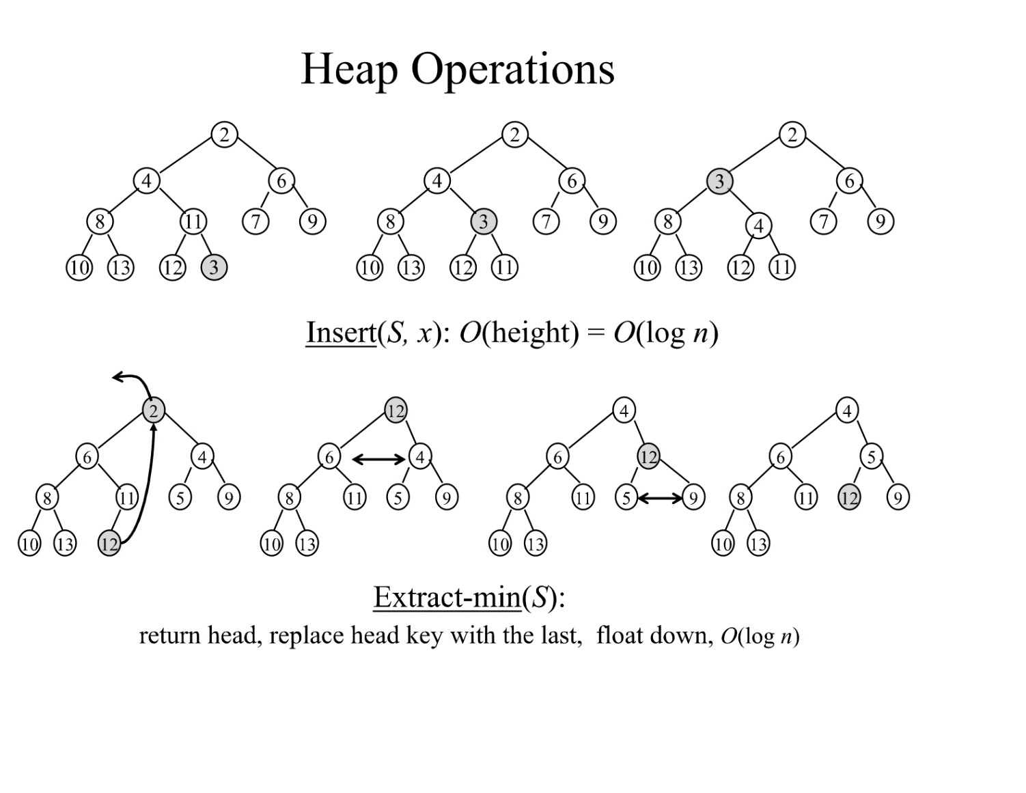

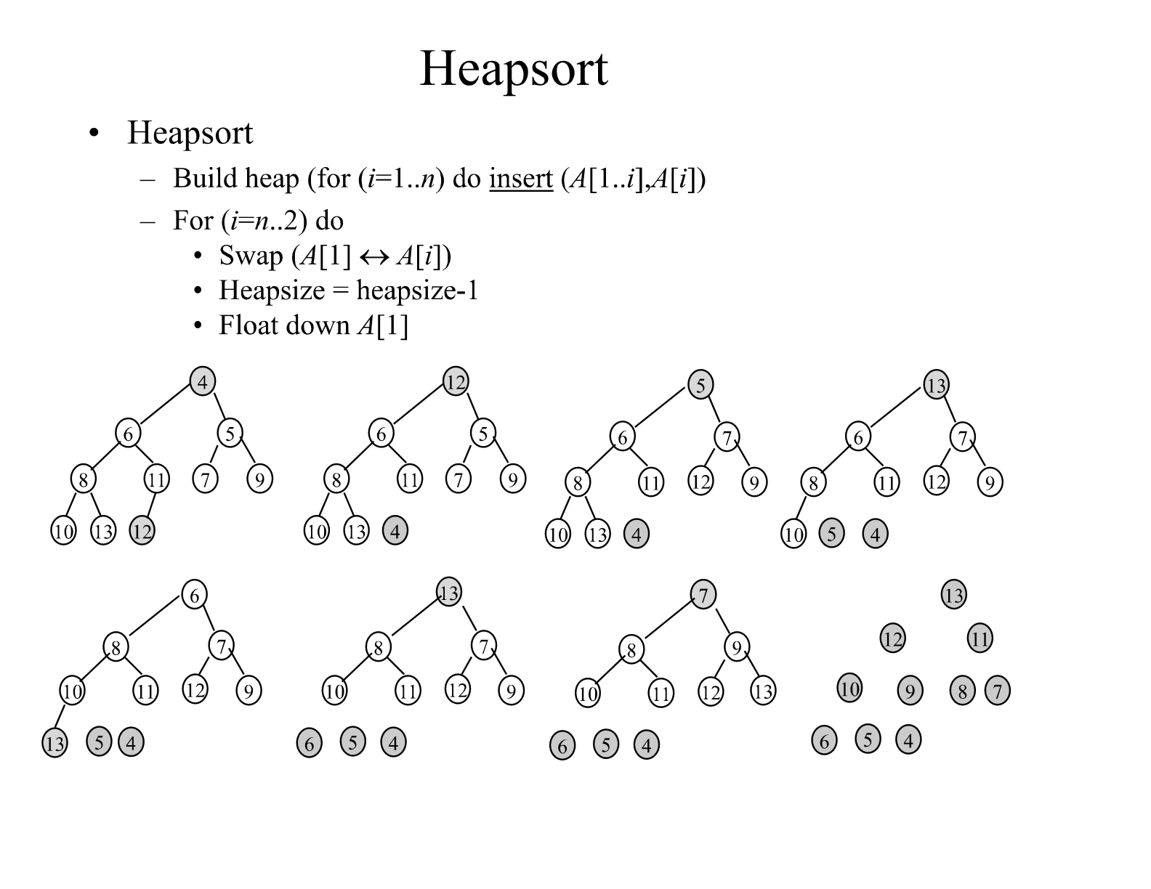

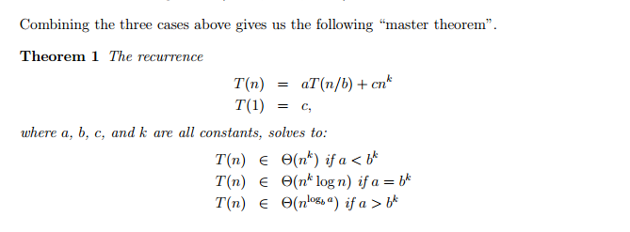

**a. T(n) = 2T(n/2) + n4.**

a = 2

b = 2

c = 4

Therefore, bc = 24 = 16

Since a < bc = 2 < 16, apply the Case 1 mentioned above in the explanation of the master theorem.

Hence, the running time of the T(n) is as follows: 🡪 Θ(nc) = Θ(n4)

**b. T(n) = T(7n/10) + n.**

a = 1

b = 10/7

c = 1

Therefore, bc = (10/7)1 = 10/7

Since a < bc = 1 < 10/7, apply the Case 1 mentioned above in the explanation of the master theorem.

Hence, the running time of the T(n) is as follows: 🡪 Θ(nc) = Θ(n)

**c. T(n) = 16T(n/4) + n2.**

a = 16

b = 4

c = 2

Therefore, bc = (4)2 = 16

Since a = bc = 16 = 16, apply the Case 2 mentioned above in the explanation of the master theorem.

Hence, the running time of the T(n) is as follows: 🡪 Θ(nc log n) = Θ(n2 log n)

**d. T(n) = 7T(n/3) + n2.**

a = 7

b = 3

c = 2

Therefore, bc = 32 = 9

Since a < bc = 7 < 9, apply the Case 1 mentioned above in the explanation of the master theorem.

Hence, the running time of the T(n) is as follows: 🡪 Θ(nc) = Θ(n2)

**e. T(n) = 7T(n/2) + n2.**

a = 7

b = 2

c = 2

Therefore, bc = 22 = 4

Since a > bc = 7 > 4, apply the Case 3 mentioned above in the explanation of the master theorem.

Hence, the running time of the T(n) is as follows: 🡪 Θ(nlogba) = Θ(nlog27)

**f. T(n) = 2T(n/4) + sqrt(n)**

a = 2

b = 4

c = 1/2

Therefore, bc = (4)1/2 = 2

Since a = bc = 2 = 2, apply the Case 2 mentioned above in the explanation of the master theorem.

Hence, the running time of the T(n) is as follows:🡪Θ(nc log n) = Θ(sqrt(n) log n) or Θ(n1/2 log n)

**g. T(n) = T(n – 2) + n2**

The relation is not of the form T(n) = aT(n/b) + f(n), hence it cannot be solved by using the master theorem. You have to solve the relation by using the expansion method.

The solution of the recurrence relation is therefore as follows:

T(n) = T (n – 2) + n2

= (T(n – 4) + n2) + n2

= ((T(n – 6) + n2) + n2) + n2

= ((T(n – n) + n2…) + n2) + n2) + n2

= ((1 + n2…) + n2) + n2) + n2

= 1 + n/2(n2)

= 1 + n3/2

Hence the running time of the algorithm is as follows: 🡪 Θ(n3)

